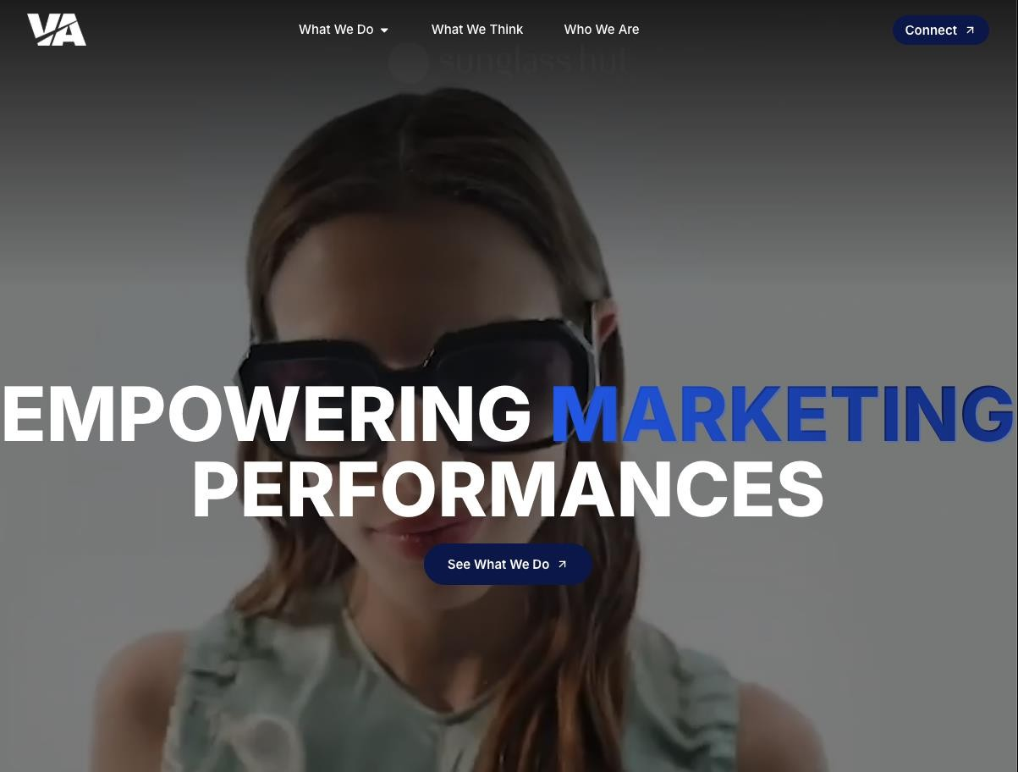
Aura

Add a fourth menu item referring to AURA on the current website.

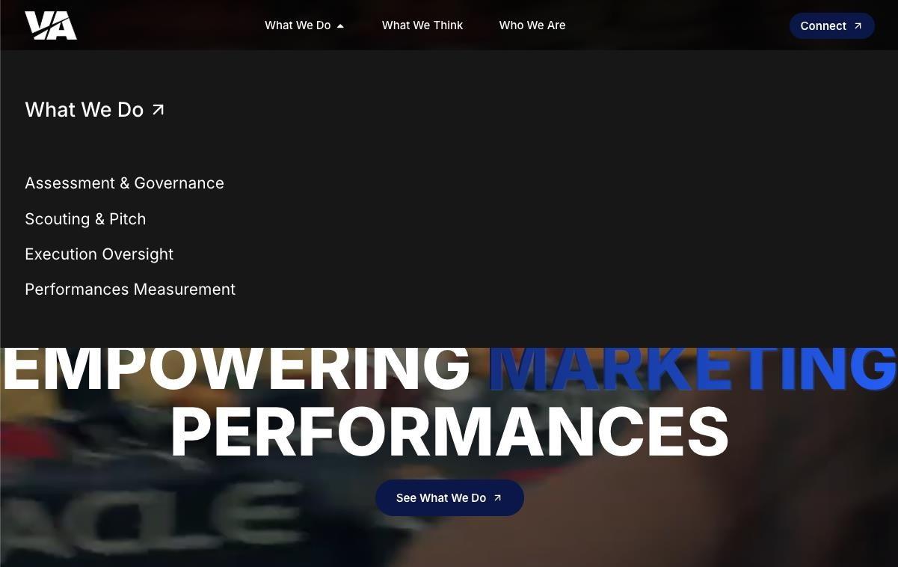
The fourth menu item will replicate the current “What We Do” dropdown structure.
Aura
Aura
DB
workflow
Etc…
It will therefore include sub- links directing to the tool’s functionalities (names to be defined).
Yours will be labelled “DB” and will link to the portal you are currently developing.

I would prefer to use
icons similar to those on AdForum, but centrally aligned.
Aura
Not needed, you can remove

This section should consist of two
buttons:
Sign in → to remain as it is.
Sign up → to direct users to a page where they can choose how to register: either as a supplier wishing to register, or as a client seeking greater visibility into agency data.
The Sign up button should adopt the same design as the current Connect button.

To be define, at this stage you can keep the possibility to write a text

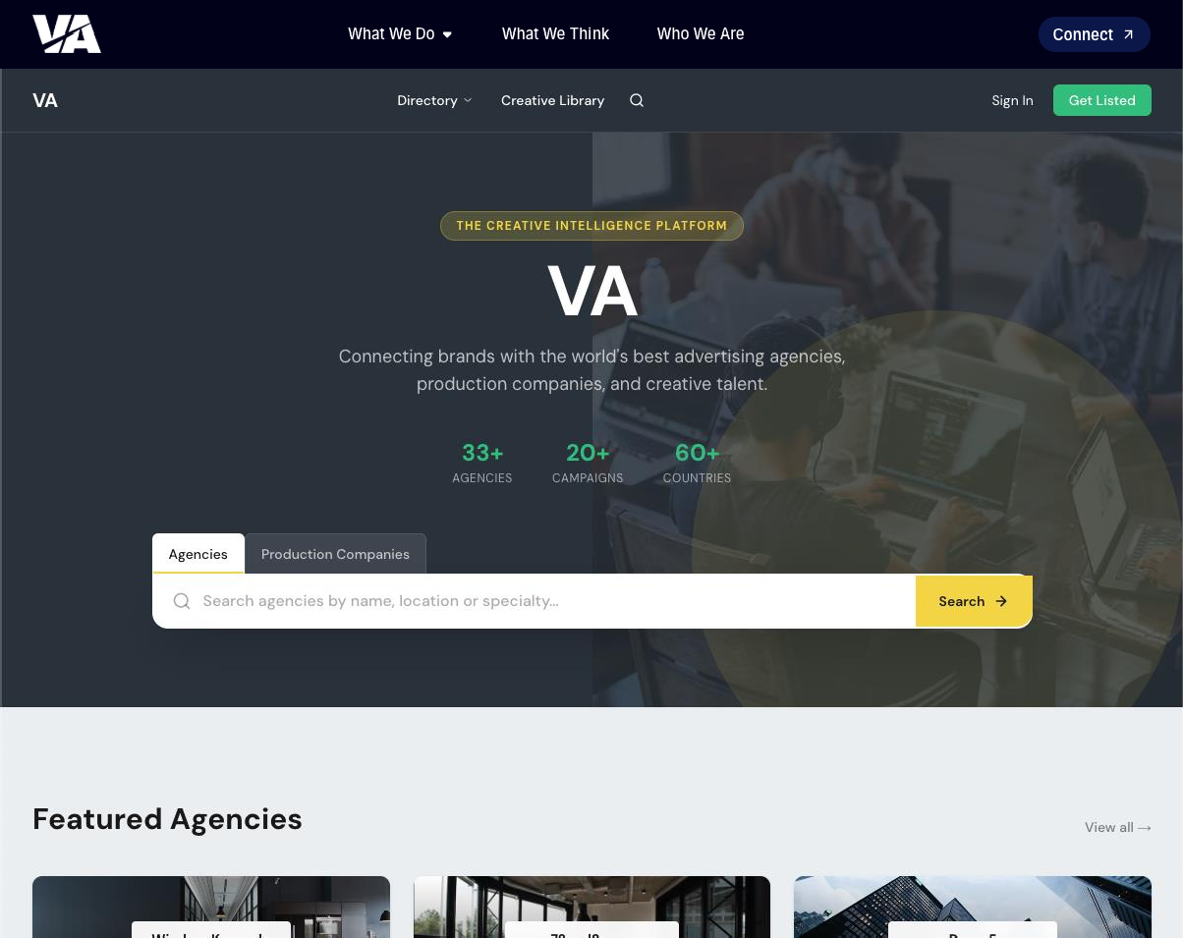


The search bar must align with the
website’s template design; it cannot be squared.
It should have the same thickness as the current search bar, but with an oval shape — consistent with the buttons and with the title you have inserted.

Remove

I assume the logo will be
placed here, using the same
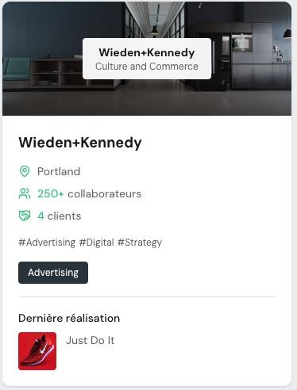
format as Scanbook.

Add another item «award»

The white used for the cards
should be reconsidered so that it sits properly against the dark blue background.
In any case, we can address the colour palette in more
detail at a later stage.

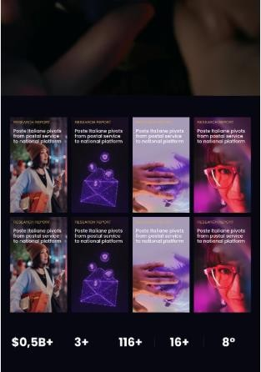
Background must be on the same color of our current website #02030E

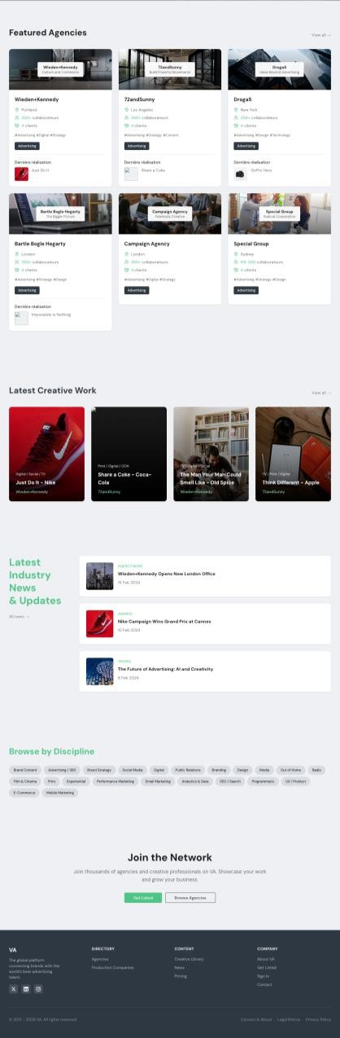

Where are these #tags coming from? We miss see more agencies (no more than 6 in a block request by request

Hide this section maybe in a
second moment we can
connect what we already have
on our website

Remove this section

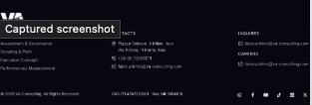
Ok but we need to think at a copy as «join the network» as a client or as vendor with the
same sign up
I guess you will take our footer once you will embed in our template

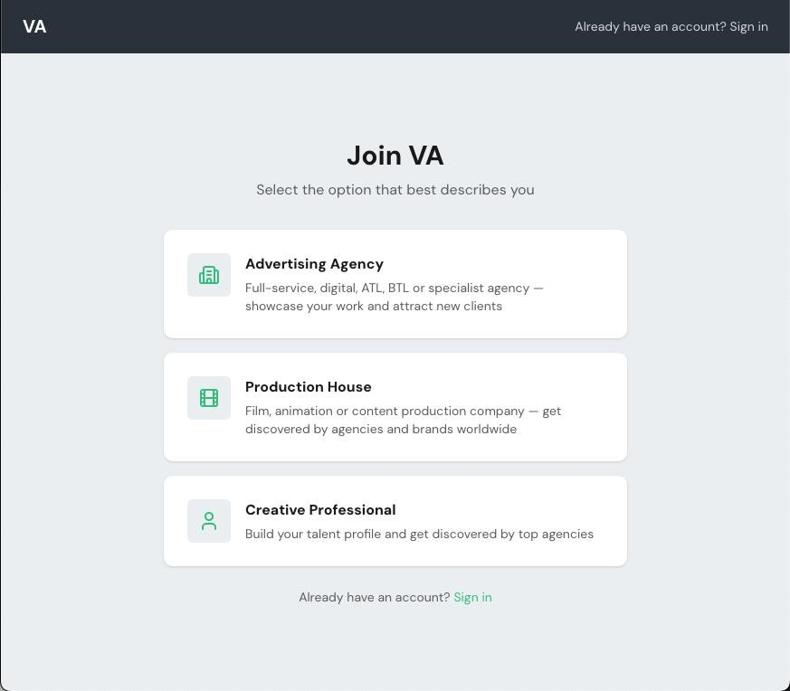
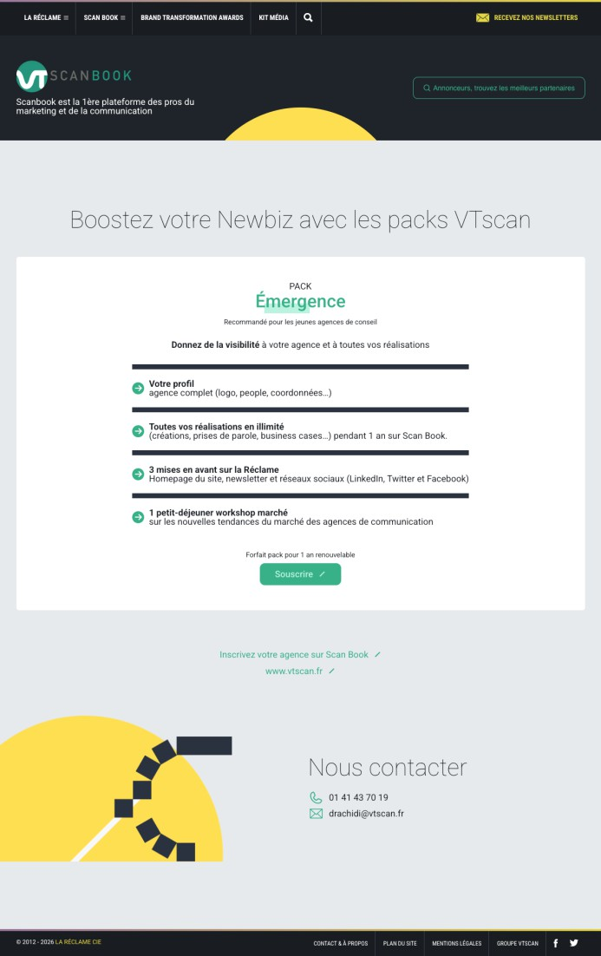
Always under main menu remove

Please follow the creative
guidelines of previous pages regarding menu, background and footer (do we need a footer here?
We miss Client

We need to review the copy, no problem at this stage

Hide at this stage, we can use in a second moment. Now we don’t have time to dedicate to creative provessional

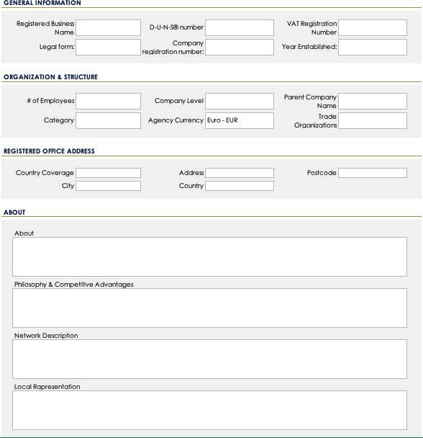
Step 1 «general Info» can include all these requests
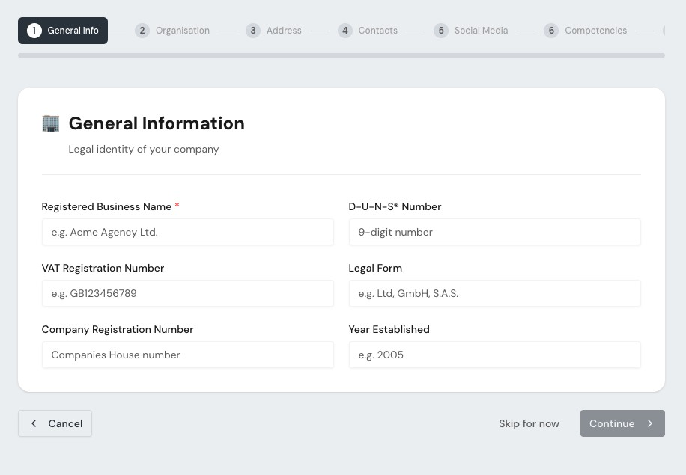

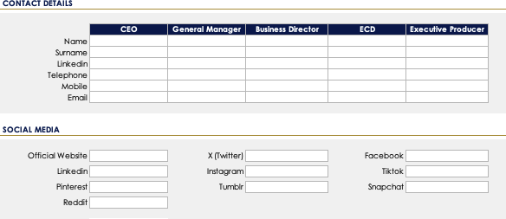
Step 2 «Contacts» can include all these requests


Step 3 «Turnover C Clients» can
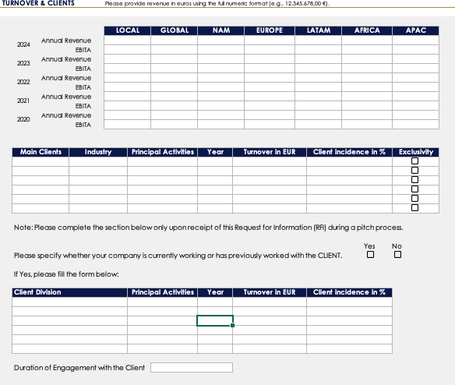
include all these requests
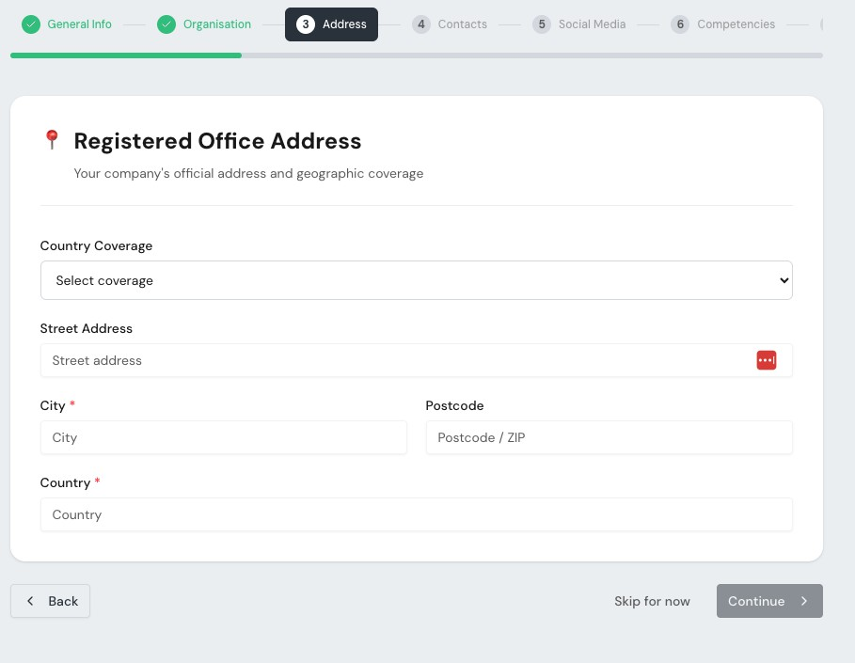


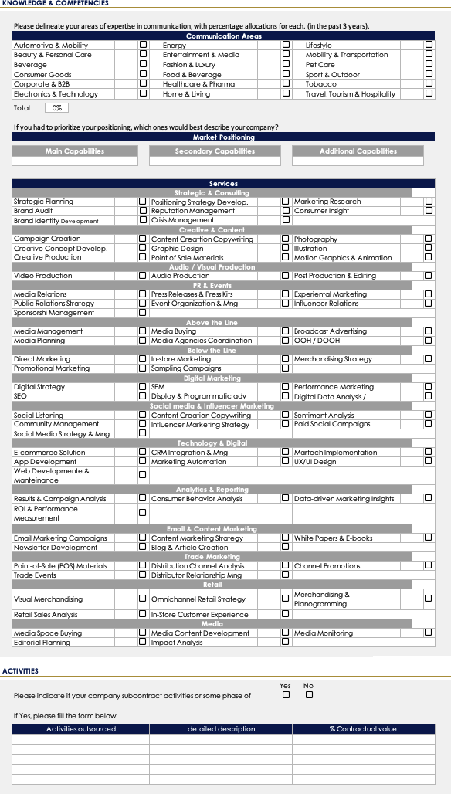
Step 4 «Knowledge C Competencies» can include all these requests

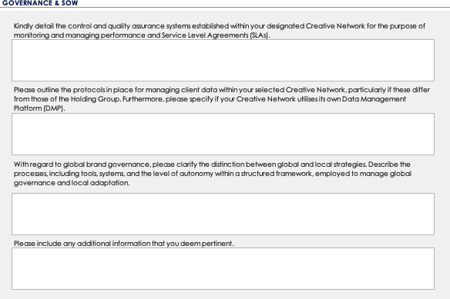
Step 5 «Governance C Sow» can
include all these requests
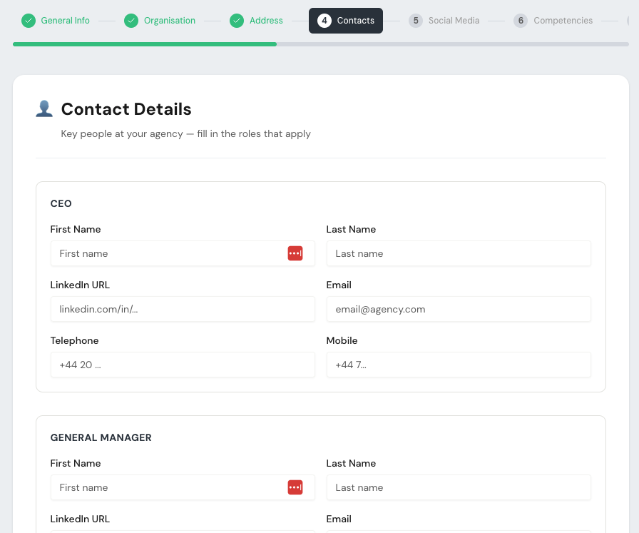

Step 6 «People C Talent» can include
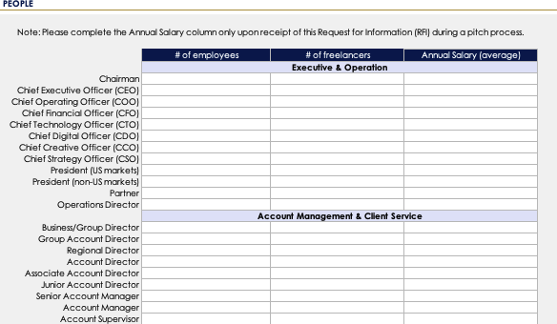
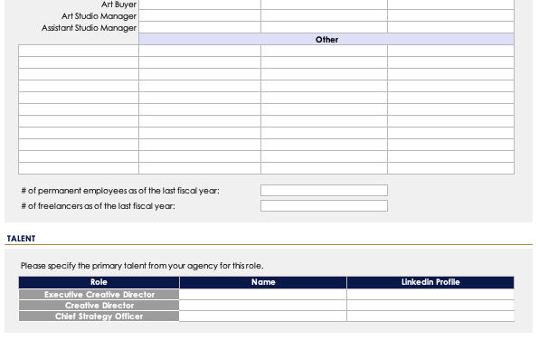
all these requests

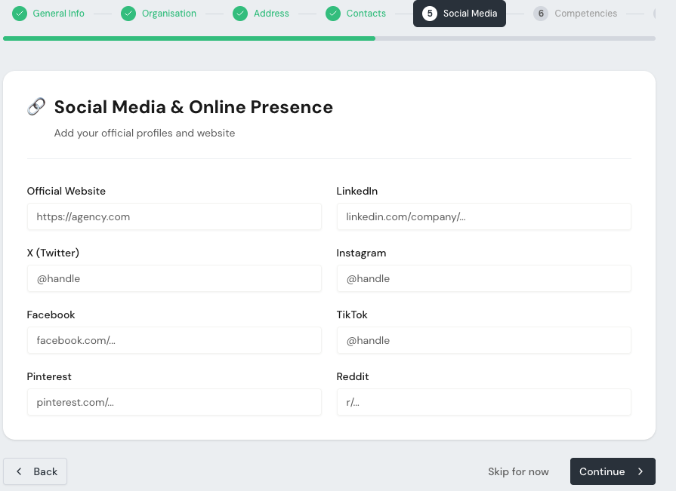
Full version, i’ve just create a short pitcture to stay in this chart

Step 7 «Award C Infos» can include
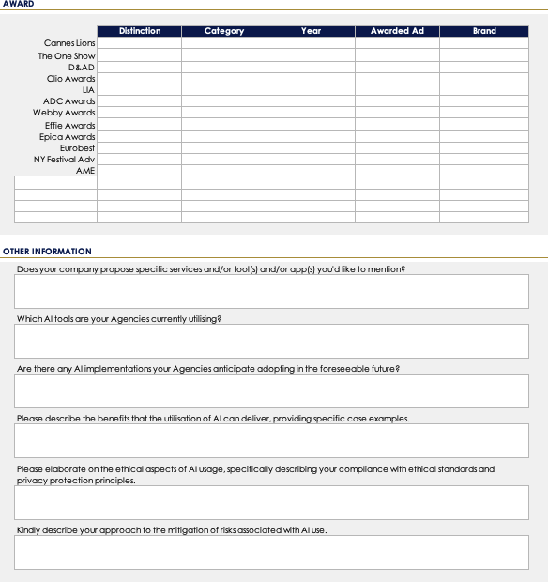
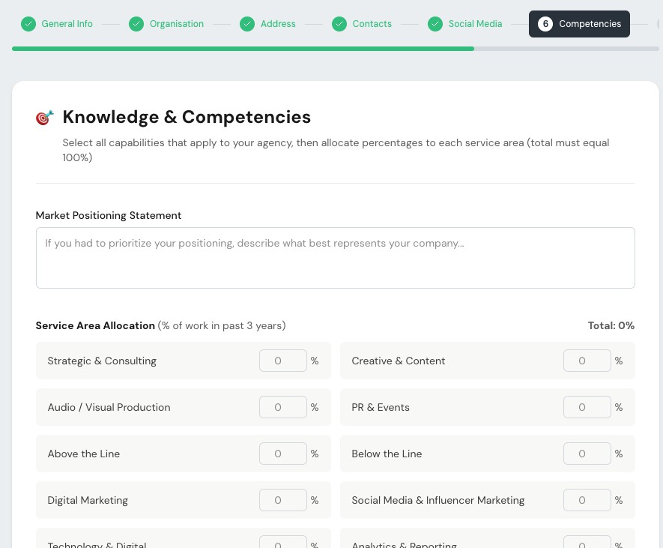
all these requests

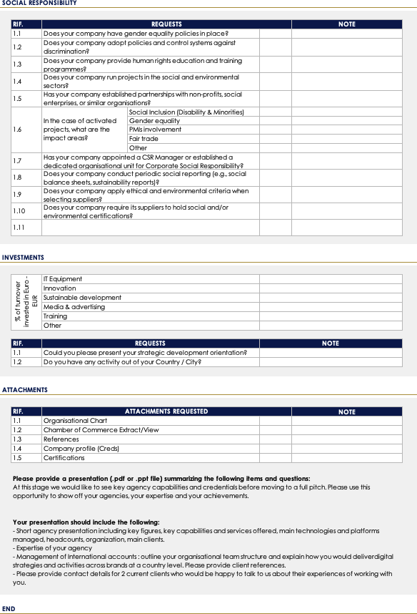
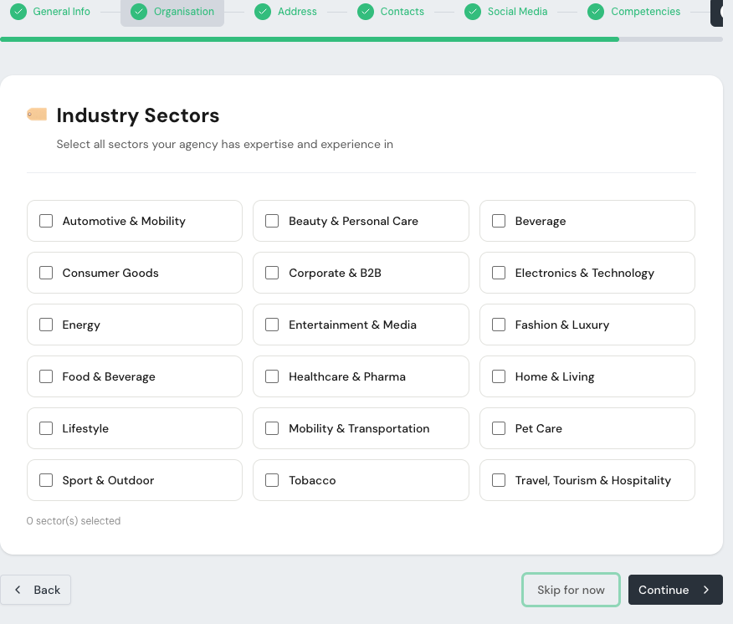
Step 8 «Add On» can include all
these requests

Beyond the visual aspect, what is fundamentally important is that the super admin must be able to modify the fields within the registration sections and/or add new stages with additional sections.
Another important note: in the Turnover s Clients section, the years must update automatically. We require a five-year historical view; therefore, in 2026 we would request 2025, 2024, 2023, 2022, 2021. In 2027, we would request 2026, 2025, 2024, 2023, 2022, and so on. This must update automatically.
Additional relevant technical aspects:
When a user completes the registration process, the profile must undergo our review before being published. Final approval and publication must be granted by us.
Users must not be allowed to register with personal email addresses. A restriction should be implemented to accept only corporate domains.

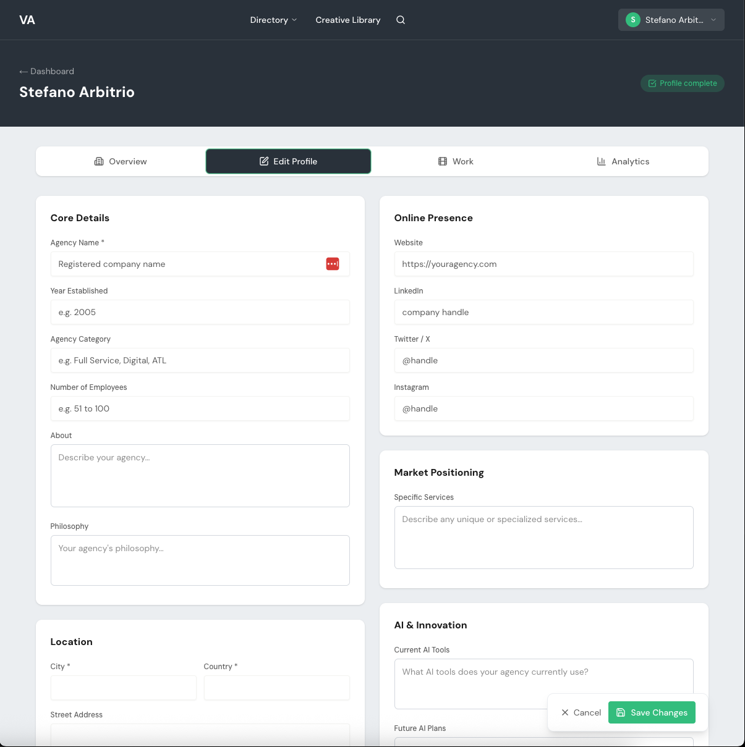

Keep the menu
Aura
Move here the user icon

Keep the same dark blue

Keep the same dark blue

An important technical note: not all fields should be editable independently by the user. By when do I need to provide you with feedback on which fields can be modified autonomously and which should require our prior approval?

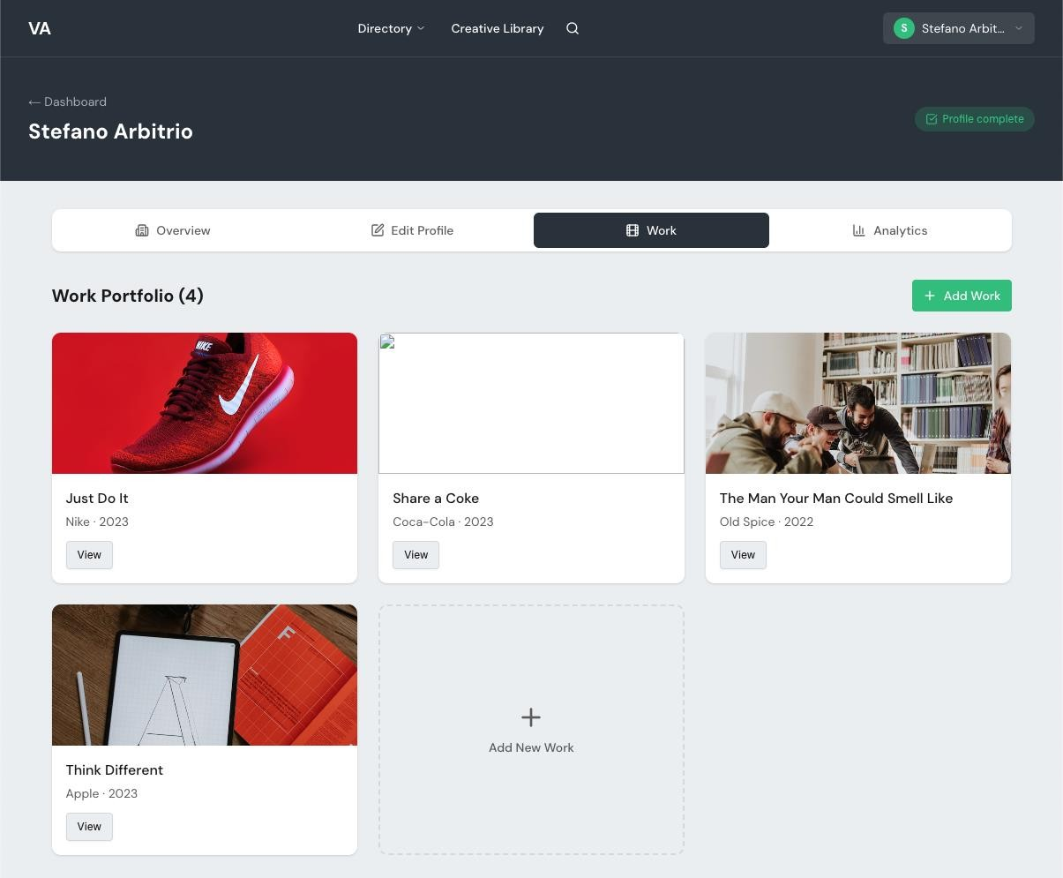

Keep the menu
Aura
Move here the user icon

Keep the same dark blue

Keep the same dark blue

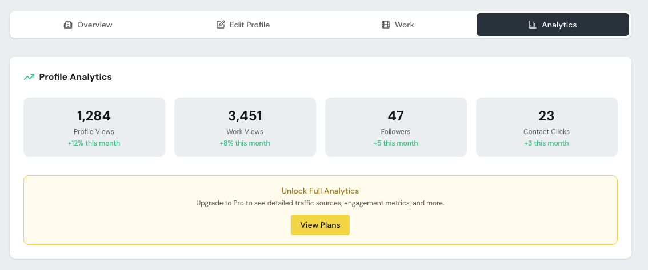
In the first phase we can hide this
section. Once the platform will be populated and it will work we can consider to share analytics

Remove and keep the same
Aura
background color

Increase the size of the logo

Consider a cover image
Ok but only if user has log in. Only the user (Client) can have a favourite list
Remove
As tab use the 8 steps of the registration form

Use website background

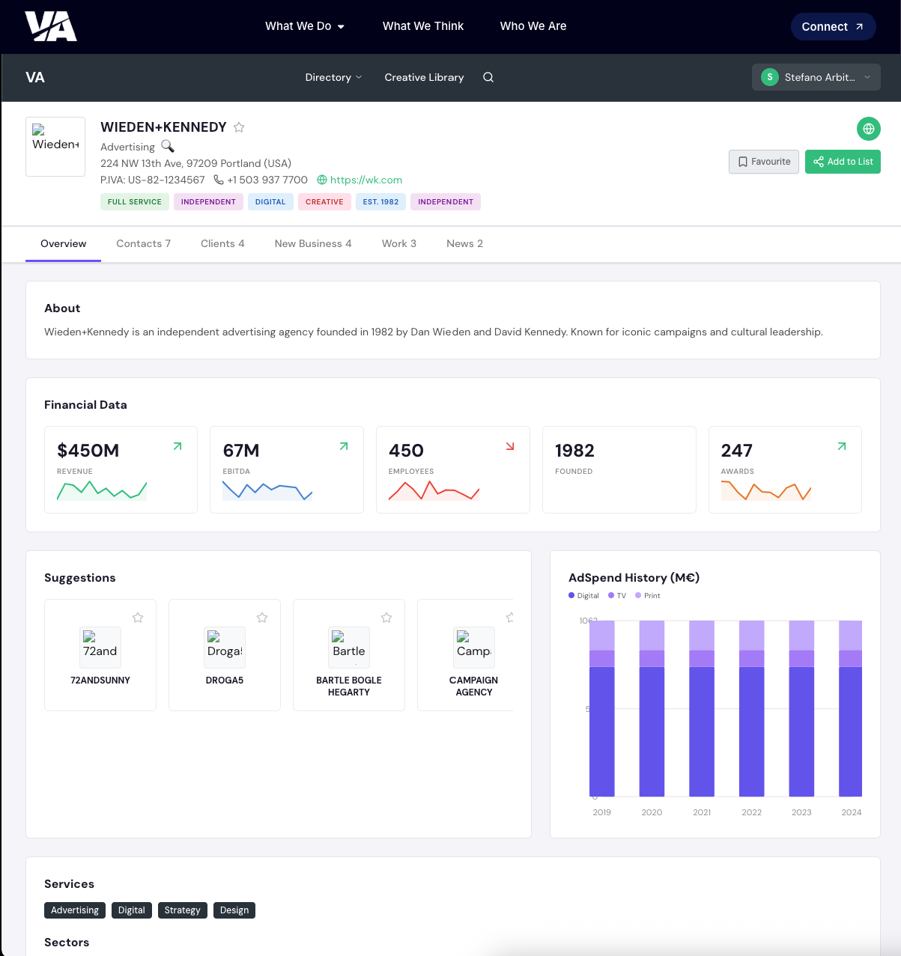
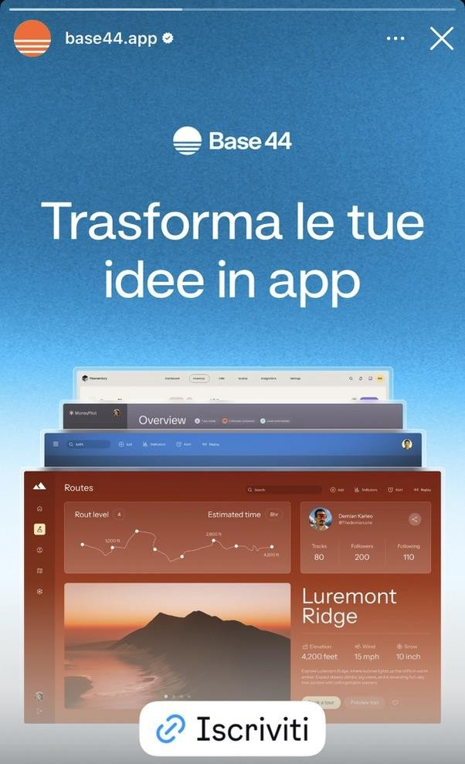
Fancy but not
enough.
We should also consider that we will be positioning and selling the
platform partly on
its aesthetic appeal,
particularly in
terms of how it
showcases agency
profiles.
It is therefore
essential that the
pages adopt a
refined, futuristic dark look and feel, in line with the example I am
sharing with you.

Not all these numbers need a
graphic for some of those an icon
its enough

